Bahria University,

Karachi Campus



LAB EXPERIMENT NO.

_______7_______

LIST OF TASKS

|  |  |
| --- | --- |
| TASK NO | OBJECTIVE |
| 1 | **Write a javascript function that takes length, width, and height values of rectangle from user. The function should find the volume of rectangle using the function-currying.** |
| 2 | **It's a general concept in mathematics where you combine two or more functions into a brand-new function. Write a javascript program to implement the given concept with the help of function-compose for the given function. f(g(x))** |
| 3 | **Write a javascript program that uses  filter() to create a filtered array that has all elements with values less than 10 removed.** |
| 4 | **Creates an array consisting of only those elements that satisfy the condition checked by isPositive() function with the help of appropriate javascript advance loops concept.** |
| 5 | **Write a javascript program that implements the array.**map()**that aim to produces an array containing square roots of the numbers in the original array.** |
| 6 | **Write a javascript program to create the Promise that resolve in 10 seconds and check the status by returning the “Promise is resolved successfully” string if the number is even otherwise reject the promise by returning the string “Promise is rejected”. Convert this task unto async await as well and compare the results.** |

Submitted On:

_14-12-2022_

(Date: DD/MM/YY)

**LAB # 07**

**Task # 01: Write a javascript function that takes length, width, and height values of rectangle from user. The function should find the volume of rectangle using the function-currying.**

**Solution:**

<body>

    <Label for="height">Enter Height:</Label>

    <input type="text" id="height"><br><br>

    <Label for="width">Enter Width:</Label>&nbsp;

    <input type="text" id="width"><br><br>

    <Label for="result">Result:</Label>&nbsp;&nbsp;&nbsp;&nbsp;&nbsp;&nbsp;&nbsp;&nbsp;&nbsp;&nbsp;

    <input type="text" id="result" readonly><br><br>

    <input type="button" value="Calculate" onclick="res()">

</body>

<script>

    let res=()=>{

        let h=+document.getElementById("height").value

        let w=+document.getElementById("width").value

        document.getElementById("result").value=area(h)(w)

    }

    let area=(height)=>{

    return(width)=>{

        return height*width

    }

}

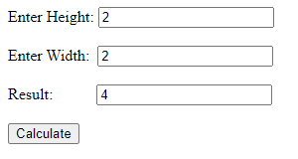**Output:**

**Task # 02: It's a general concept in mathematics where you combine two or more functions into a brand-new function. Write a javascript program to implement the given concept with the help of function-compose for the given function. f(g(x))**

**Solution:**

const compose=(f,g)=>x=>f(g(x))

const fx=(x)=>x*x*x

const gx=(x)=>2*x

const composeFun=compose(fx,gx)

console.log(composeFun(2))

**Output:**

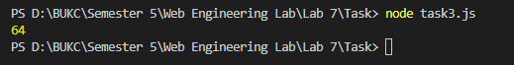

**Task # 03 Write a javascript program that uses  filter() to create a filtered array that has all elements with values less than 10 removed.**

**Solution:**

function myfunction(values){

    return values>=10

}

let a="Array: ";

arr=[4,5,8,23,54,1,45,7,45,22,3]

for(let i=0;i<arr.length;i++){

    a+=arr[i]+" "

}

console.log(a)

console.log("Filtered Array: "+arr.filter(myfunction))

**Output:**

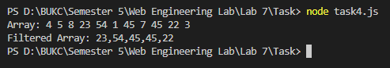

**Task # 04: Creates an array consisting of only those elements that satisfy the condition checked by isPositive() function with the help of appropriate javascript advance loops concept.**

**Solution:**

function myfunction(values,index,array){

    if(values>10){

        return values

    }

}

arr=[4,5,8,23,54,1]

console.log("Array 1:")

for(let i=0;i<arr.length;i++){

    console.log(arr[i]+" ")

}

console.log("New Array :")

let new_Array=arr.filter(myfunction)

for(let i=0;i<new_Array.length;i++){

    console.log(new_Array[i]+" ")

}

**Output:**

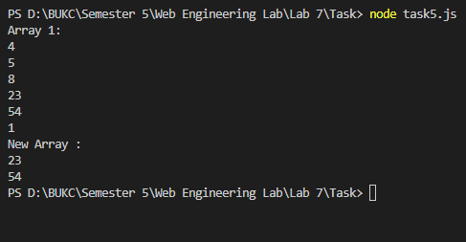

**Task # 05: Write a javascript program that implements the array.map() that aim to produces an array containing square roots of the numbers in the original array.**

**Solution:**

function myfunction(value){

    return Math.sqrt(value)

}

arr=[25,16,9,4]

new_arr=arr.map(myfunction)

console.log("Array:")

for(let i=0;i<arr.length;i++){

    console.log(arr[i])

}

console.log("New Array:")

for(let i=0;i<new_arr.length;i++){

    console.log(new_arr[i])

}

**Output:**

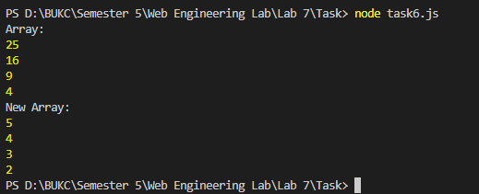

**Task # 06: Write a javascript program to create the Promise that resolve in 10 seconds and check the status by returning the “Promise is resolved successfully” string if the number is even otherwise reject the promise by returning the string “Promise is rejected”. Convert this task unto async await as well and compare the results.**

**Solution:**

**HTML Code:**

<body>

    <label for="num">Enter Number: </label>

    <input type="text" id="num">&nbsp;&nbsp;<button onclick="check()">Check</button>

    <script src="task9.js"></script>

</body>

**JS CODE:**

let check=()=>{

    let num=+document.getElementById("num").value;

    const proms= new Promise((resolve, reject) => {

        setTimeout(() => {

            if ((num%2)==0) {

                resolve ('Promise is resolved successfully.')

            } else {

                reject ('Promise is rejected')

            }

        }, 10000);

    });

    proms.then((result) => {

        alert(result)

    })

    .catch(function(error){

        alert(error)

    });

    }

**Output:**

